 **13 Feb 2015** **The Weekly Bulletin of Rotary Club of Kathmandu Mid-Town** **bc-31/2.015**

|  |
| --- |
|  |

District: 3292 Web:www.rotarymidtown.org.np Club Id: 26776

**FEBRUARY IS WORLD UNDERSTANDING MONTH**

World Understanding Month is dedicated for

Rotary’s continued quest for goodwill, peace and understanding

among people of the world.

Club’s Weekly Meeting # 1265 on Friday, 6 February:

Extracts of the Meeting Minutes are given below:

“1. President Kul called meeting #1265 to order.

“6. Rtn Sheri introduced the Guest Speaker Mr. Chris Koch, Motivational Speaker, Farmer & Travel Bum

“7. Chris spoke on “If you can..” He said that if you worry about yourself you miss opportunities in life. He said he is

thankful about his parents who made him become independent, “if they did everything, I would not have been

independent.

“Dont Worry about what you dont have, but, worry about what you have.”

“8. President Kul then opened the floor. Rtn Buddha, Rtn Govinda, Rtn Rabi took part in the discussion. Rtn Larry gave

vote of thanks to Chris.

”9. Information sharing:

> Gopal Kamala Rajbhandary Award for Vocational Excellence is being awarded to Scholar Satya Mohan Joshi.

> The Rotary Peace Conference was being held from 7-9 FEB.

> President Elect Paras informed about the new board. He also requested all to update their DOB, Spouse and

Anniversary details on the roster.

> PP Mani informed about the Gift of Sight held on 30 January. Along with PP Mani, PP Ajay and PP CK also visited

the site.

> PP Komal informed about the Saturday Walk on March 7 to Chitlang, where Rtn Dr Sumitra is coordinating a

Mahila (Women) Bank.

> PP Ambika informed that the RI President is here for the next couple of days in context of Rotary Peace Conference.

“9. Statistics of the meeting: Members present: 22”.

# Weekly Meetings and Programs :

|  |  |  |
| --- | --- | --- |
| Date | Program/ Speaker | Topic of Presentation |
| 13 February | Dr Andrew Trotter | . |
|  |  |  |
|  |  |  |

Friday, 13 February:

Our Guest Speaker is Dr Andrew Trotter. He is an expert on HIV/AIDS. Dr Trotter, a doctor of internal medicine is currently associated with the TU Teaching Hospital in Kathmandu since 2013 as Honorary Assistant Professor, Internal Medicine and HIV Unit, Institute of Medicine, Tribhuvan University

Dr Trotter was associated with Tufts University, Boston, USA 2010-2013 as Clinical Associate in Medicine, Geographic Medicine and Infectious Disease,

**New Team for 2015-16**

President-Elect Paras SJB Rana announced his team for Rotary Year 2015-16

Paras SJB Rana : President

Dr Shankar Sharma : President-Elect

Kul C Gautam : Immediate Past President

Peter Bodde : Vice President

Bhairaja Panday : Secretary

Shyam Thapaliya : Treasurer

Sheri Meyerhoffer : Joint Secretary

Pramod Paudel : Club Administration

R R Shrestha : Membership

Deepak Bajracharya : Public Relations

Rabi Karmacharya : Service Projects

Gobinda Chipalu : The Rotary Foundation

Dr C. Lekha Tuladhar : Youth Service

Dr Isabella C B Khadka : Sergeant-at-Arms

Club Mentor: PP William Ma Club Trainer: PP Mani D Joshi

Club Web Master: Dr Isabella C B Khadka

Club Information Technology/Management Officer: PP Arun Man Sherchan

Editor/Breakfast Chatter: Anja Moller Rasmussen

**The Gift of Sight 2014-2015**

This year’s “Gift of Sight” eye camp was held at Hetauda Community Eye Hospital

from 30th January to 2nd February 2015.

It was organized by Rotary club of Kathmandu Mid Town

with the technical support of Hetauda Community Eye Hospital.

The eye camp was financially supported by

Rotary club of Garden City - Singapore,

Rotary club of Taipei Yuanshan-Taiwan,

Rotary club of Tainan East - Taiwan,

Rotary club of Kota Famosa Malacca - Malaysia

and Past President Chong Choo Chai of Rotary club of Garden City, Singapore.

Eye screening was carried out this year in the surrounding villages of Amlekhgunj, Nakauli, Dakaila, Bahuwari and Prastoka. Bus transportation was provided back and forth for the patients at the eye camp. This is an annual project of Rotary club of Kathmandu Mid-Town and Garden City Singapore

and has been continuing for the last fourteen years.

Altogether 1204 patients were screened and

338 patients were successfully operated with Intra Ocular Lens (IOL) implant and

14 patients received minor surgery for other eye problems.

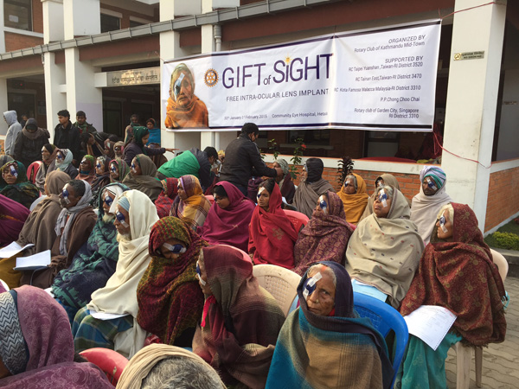 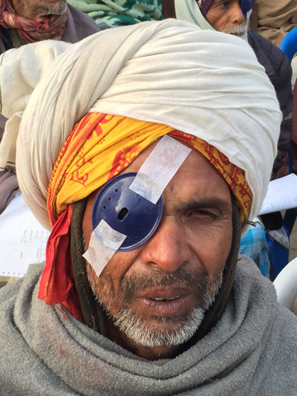

## 7th District Conference of RI District 3292

## on 27th, 28th Feb and 1st Mar, 2015 at Chitwan

## Pre-registration date has been extended up to 20th Feb 2015

## “All the Host Clubs and the organizing committee members in the leadership of Conference Chair Uttam Lal Chuke are eager to welcome you all to this 7th District Conference.

## In addition, also enjoy your fellowships in the flavor and beauty of Chitwan and National Parks.”

## Welcome to Chitwan! : DG Rabindra Piya

**“Be a Gift to the World”**



Rotary International President-elect K.R. “Ravi” Ravindran

asked Rotary members to use their talents, expertise, and

leadership to transform the lives of others when he announced

his theme for the 2015-16 year, ***Be a Gift to the World***,

during the International Assembly in San Diego, California,

USA.

RI President-elect K.R. Ravindran called Sunday's address

to incoming district governors the "most significant moment

of my life."

"All of you have been given ………….. (More in Annex)

*Source: Ryan Hyland / RI News*

Travel / Tourism

Travelling is a great fun.

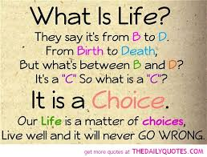

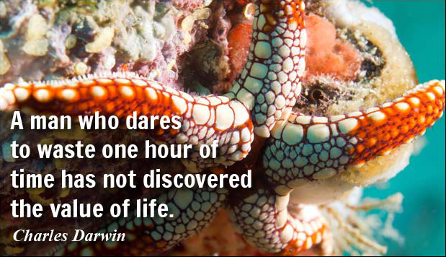

**A THOUGHT FOR TODAY:**

**[There is a wonderful mythical law of nature that](http://www.brainyquote.com/quotes/quotes/b/baruchspin101666.html" \o "view quote)**

**[three things that we crave for most in life](http://www.brainyquote.com/quotes/quotes/b/baruchspin101666.html" \o "view quote)**

**[- happiness, freedom, and peace of mind,](http://www.brainyquote.com/quotes/quotes/b/baruchspin101666.html" \o "view quote)**

**[are always attained by giving them to someone else.](http://www.brainyquote.com/quotes/quotes/b/baruchspin101666.html" \o "view quote)**

**[Let us all share our happiness !](http://www.brainyquote.com/quotes/quotes/b/baruchspin101666.html" \o "view quote)**

On Lighter Side:

**When you're right, no one remembers.**

**When you're wrong, no one forgets !**

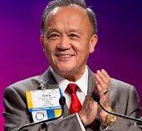

I've heard stories of how our service changes the lives of others, and how it changes us as

Rotarians. When I hear these stories, I can't help but wonder: How many other lives could

we change for the better by bringing more people into Rotary? And how many more people

could we bring into Rotary simply by sharing our own Rotary stories?

**RI President GARY C.K. HUANG**

## 13 February 2015 The Weekly Bulletin of Rotary Club of Kathmandu Mid-Town bc-31/2.015

*******************************

Annex

"…… All of you have been given so many gifts. And you have now been given this great gift: one year to take all your talents, all your gifts, everything that you are and can become -- and Be a Gift to the World," said Ravindran, revealing his presidential theme at the annual five-day training meeting in San Diego, California, USA. "You have one year to take that potential and turn it into reality. One year to lead the clubs in your district and transform the lives of others. The time is so short, yet there is so much to be done."

Highlighting Rotary's biggest challenge, the eradication of polio, Ravindran said, "A future without polio is a gift that we have promised to the children of the world. And indeed it is a gift that we will give."

Ravindran, a member of the Rotary Club of Colombo, Sri Lanka, used Rotary's successes in the fight to eradicate the disease as an illustration of the impact Rotary members can have in the world. When Rotary set a goal of eradicating polio 25 years ago, it was endemic in 125 countries, and more than 1,000 children were becoming paralyzed each day. Today, polio remains endemic in just three countries, Afghanistan, Nigeria, and Pakistan. And in all of 2014, only 333 cases were reported. "We will battle on. We will prevail," he said.

Ravindran discussed some of Rotary's other challenges, including membership.

"We have to find a way to bring back the fundamentals that built our organization: the emphasis on high ethical standards in all aspects of our lives, and the classification system that encourages a diversity of expertise in each club," he said. "Too often these ideas are viewed as little more than inconvenient obstacles to increasing our membership. But they have been essential to Rotary's success, and we ignore them at our own peril."

Ravindran told attendees that the focus on branding is essential to helping Rotary grow. "We need to reposition our image, which we recognize has faded in many parts of the world," he said.

Rotary also needs to continue to raise funds for The Rotary Foundation, attract new members, and encourage greater participation from current members, he added.

"There are no easy answers to any of these questions. And yet the answers must somehow be found. We are the ones who must find them," said Ravindran.

The president-elect closed his speech emphasizing that now is the time to make real change.

"You have one year to build monuments that will endure forever, not carved in granite or marble, but in the lives and hearts of generations. This is our time. It will not come again. Let us grasp it," he said.